MINISTRY OF EDUCATION & TRAINING
LONG AN UNIVERSITY OF ECONOMICS AND INDUSTRY
PERMANENT TRAINING CENTRE


GRADUATION PRACTICUM REPORT

Practicum site : Long An University of Economics and Industry
Practicum period : September 07th, 2019 to November 24th, 2019
Practicum supervisor : Ms. NGUYEN PHUC DIEN NGOC
Practicum student : PHAN THI THUY TRANG
Class : 18BAV1

Ho Chi Minh city, November 24th, 2019

ACKNOWLEDGEMENTS

English has been an international language for a long time, and I am also one of the million people who try to master it. It is cannot be denied that English is a very useful tool for communication, but I think I get more benefits than that. First, English helps me to be more confident as I have to talk a lot if I want to be good at speaking skill. By learning English, it is not just improved in my confidence, but I can also develop my presenting as well as communicating skills. Second, English offers me a bright way to access to the world, and my mind has been opened widely since I learned it. I read more books, watch more TV programs and know more news, and all of them are in English. I developed a habit of reading so that I can both learn new words and gain more knowledge at the same time. Third, my mentality has been brought to another level thanks to English
After completing all subjects of Diploma 2 in English for 2 years, we have had more 8-weeks practicum period. And I hope all this will succeed.
First, I would like to thank MA. Nguyen Phuc Dien Ngoc - Acting Dean of Foreign Language Department of ​​Long An University of Economics and Industry- who has been very supportive of me in completing the graduation practicum report. So I want to express my deep gratitude for her guidance as well as her great contribution and correction to my practicum report.
And I would like to thank all the lecturers of Long An University's, Long An Vocational Training Center.
I also thank my friends for helping me during my practicum period.
Thanks for giving us the time we have discussed together, the time we have learned together sharing knowledge and having fun!
Thank you very much again for everything!

Phan Thi Thuy Trang

THE PRACTICUM SITE’S COMMENTS

Verification from Practicum Site:

Signature :
Fullname :

THE PRACTIUM SUPERVISOR COMMENTS

Vertification from Practium Site:

Signature:
Fullname:

TABLE OF CONTENTS
ACKNOWLEDGEMENTS
THE PRACTIUM SITE'S COMMENT
THE PRACTICUM SUPERVISOR COMMENTS
TABLE OF CONTENTS
1. CHAPTER 1:
GENERAL INFORMATION OF TAN THANH DAT COMPANY 1
1.1. Overview of the practicum company: 1
1.2. Our Philosophy 2
1.3. Our objectives 2
1.4. Our Services 2
1.5. Our Staffs 3
1.6. Customer’s policies 5
2. CHAPTER 2:
DAILY ACTIVITIES REPORT AT INTERNSHIP COMPANY 6
2.1. General view of my internship position and division 6
2.2. Daily activities report at Sale department 7
2.3. The work’s schedule is assigned during the internship 7
3. CHAPTER 3
RECOMMENDATIONS TO IMPROVE IN WORKING SKILLS 13
3.1. The results that I contributed to internship company 13
3.2. The experiences gained when working in the sales department 13
3.3. The experiences can be applied in life 15
3.4. Solutions to improve the operational efficiency of the sales department 16
CONCLUSION 20

CHAPTER 1

GENERAL INFORMATION OF TAN THANH DAT COMPANY

Overview of the practicum company:
Tan Thanh Dat is a leading Real Estate company in Vietnam, specializing in Investment - Construction - Services providing superior products to enhance the value of life.
In November 2009, Tan Thanh Dat officially entered the Vietnamese real estate market. Over 10 years of establishment and development, Tan Thanh Dat always stands firm with the goal of bringing customers the best real estate products with the most professional services.
With a strong financial potential, solid experience, and a staff of highly trained, enthusiastic, motivated, creative and effective employees, Tan Thanh Dat strives constantly in every effort. In order to assert and enhance its position in the Vietnamese real estate market, maintain trust in the minds of customers and partners.
With a multi-industry, multi-ownership and multinational strategy, Tan Thanh Dat advocates joint ventures, partnerships and cooperation with financial institutions, banks, technology, large and foreign real estate corporations, countries to optimize competitive advantage in the market. Tan Thanh Dat is one of the businesses with its own culture, creating an ideal environment for people to develop their careers in real estate, while promoting the business development goals associated with the development. society, there are always practical actions to join hands for a sustainable and compassionate community.
With the available strength and determination, we believe that Tan Thanh Dat has the basis for achieving the set strategic goals and expand to the world in the near future.
We had three branches:
Ho Chi Minh city Office:
Branch1: 46/28 Nguyễn Cửu Vân, Phường 17, Quận Bình Thạnh, TP.HCM
Branch2: B105 New Sai Gon high-class apartments, Nguyen Huu Tho Street, Phuoc Kieng Ward, Nha Be District, HCMC, Viet Nam, Tel: +84 08 37764202, Hotline: +84 91 322 9278.
Da Nang Office:
114 Nguyen Van Linh Str, Hai Chau District
Tel: + 84 5113 222888, Fax: + 84 511 3222888
Mobile: +84 944 222 888
Logo of the Tan Thanh Dat Company


  - Our Philosophy:
TTD aims to be the best service provider for foreigners living in Vietnam ! With many years experience in property rental and real estate, TTD is a trustable place for expats in Vietnam to find rental properties. We offer a wide range of services from office , retail, to residental rental. TTD is committed in providing professional, efficient, flexible and friendly services that suit individual client and their family needs with the emphasis of ensuring successful and stress-free relocation to Vietnam. Our service is not only from the beginning but throughout your living time in Vietnam. TTD team is ready to assist you to deal with everything related to your stay in Vietnam. TTD conducts the business based on an ethical, fair-trading and compliant business relationship with both corporate clients and suppliers.
1.3. Our objectives:
· Uunderstanding very well requirements of our customers, provide them the cost-effective and time-saving service.
· Providing of useful information to clients and their families, pre- and post arrival, designed to assist their adaptation to their new life in Vietnam.
· Building a strong customer relationship. We want Vnrenting to become a trustable, reliable, friendly place for expats living in Vietnam.
  - Our Services
We're very proud to be your service provider.
Tan Thanh Dat has subsidiaries and each of them provide separate service:
Tan Thanh Dat Property Rental: Specialised in properties for rent: Villa, Apartment, House, Office, Showroom, Warehouse, ..( No commission from tenant ).
Vnrenting Office Expert : Specialised in Building Management, Exclusive agents, Office leasing consultancy.
Tan Thanh Dat Design & Construction : Specialised in property design, office interior design, property construction.
Tan Thanh Dat Business Licensing &Franchising: You have a good business idea but there's so much trouble if you implement that as a foreigner ?? TTD Business Licensing & Franchising is a good choice. We have many ways to help you to implement your business under our business license. Many restaurants and bars has been operated by foreigners throught out Vietnam under our Business License or Franchising.
Tan Thanh Dat Car Rental : Specialised in Car Rental, We have many cars model from famous Car Brand such as: BMV, Mercedes, Toyota, Honda, Nissan, Lexus, Ford .. from 5 seats to 12 seats for rent, short-term to long-term.
Tan Thanh Dat Expat Service:
- Property management service, Home & Company Moving.
- Business Establishment, Business Investment Consultant, Real Estate Law Consultant
- Registration of Marriage in Ho Chi Minh City , Certificate of birth.
- Driving License, Convert International Driving License to Vietnam Driving License, Application for motorbike plate number & registration document.
- Work Permit, TVRO Permit, Residence Card.
- Business License Appliance, Open a branch office in Vietnam
  - Our staffs:
· Qualified and experienced management staffs are fully supportive and responsible in finding rental properties.
· All our staffs are dynamic and active in finding properties. These people bring a competitive advantage to Tan Thanh Dat comparing with our competitors.
· Staffs in making photograph are fast and accurate, they bring a latest properties on the market to our customers sometimes in only one hour.
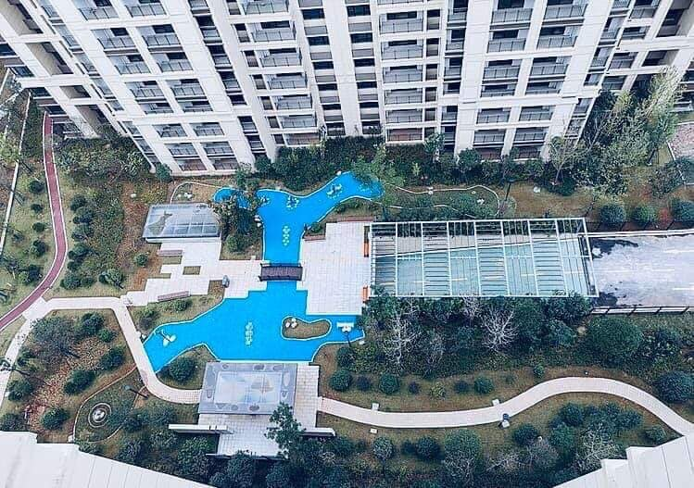

The benefits when you cooperate with us
- At Tan Thanh Dat, you will get better experiences in working.
When joining us, you will be the member of a real estate group with aspiration and dedication of bringning new values to the market. We recrute true talents and welcome them to our professional working enviroment.
- Career development
Specified and detailed career path, recognition of contribution and dedication, challenging working environment are all of foundation for you to build up your career at Tan Thanh Dat
- Health care
Yoga class, tennis club, daily fresh fruit together with ensurance package and other policies would secure for health
- Rewards
Excellent contribution and good idea are actractively rewarded in time
- Environment
Well- equipped facilities, friendly colleagues professional management board will bring you to dynamic and effective working environment.
- Other policies
Special discount up to 10% for at Tan Thanh Dat people when purchasing company projects and more.

Customer’s policies:
- To customer that buy or rent house, plat, office…
Best protection for customers, to ensure that who buy house in future can avoid the risk of losing capital when the investor fails to hand over the houses according to the committed schedule, overcoming the situation of the original owner. Investor has violated obligations committed with clients in the past time, helping the real estate market develop healthier.
Customers can feel secure when buying or renting houses formed in the future because if the investor fails to comply with the commitment, the customer has the right to ask the Bank to fulfill its guarantee obligations. Even after handing over the house, the guarantee commitment must still be valid for a certain period of time to ensure maximum benefits of customers in case of disputes arising after that time.
To investors, before selling, leasing to buy houses formed in the future, must be qualified by commercial banks to perform the investors' financial obligations to customers when their owners investment does not hand over the house on schedule as committed to the customer. Specifically, the bank will be responsible for refunding the advance payment and other payments to customers under the housing sale, lease purchase agreement and signed guarantee contract if there are the following two conditions:
+ Firstly, the investor does not hand over the house according to the committed schedule; + Second, the buyer and the lessee require the bank to perform the guarantee obligation.
- To customers that invest in plat, land, projects..
We make policies to commit profit from 5-10 years with the commitment up to 8-12% / year. This option benefits investors when there is no need to worry about profits. Especially in the first few years when a new project is put into operation, it takes time to promote, attract and stabilize room capacity, bringing regular profits. In addition, investors are also entitled to 10-12 days off / year at the project or on the system chain developed by the same investor.
Besides the form of commitment to profit in a certain period of time, we all apply profit sharing. Accordingly, the common profit sharing level is now 80:20 - investors receive 80% and investors and management units receive 20% from subleasing activities. After the commitment period, the investor will receive profit according to the sharing ratio

CHAPTER 2: DAILY ACTIVITIES REPORT AT INTERNSHIP COMPANY

2.1. General View of My Internship Position and Division
I chose an internship in the sales department, because this is the place that gives me many opportunities to develop my ability, and many other reasons such as:
I will have the opportunity to learn from those around me like the manager, the older siblings, contributing to the accumulation of living capital in dealing with a variety of classes, ages, personalities, professions. From there, I will summarize the experience for myself, learn how to grasp the psychology of others, practice the ability to read customers to have appropriate advertising campaigns, or simply talk theories. Apparel customers to buy their products.
Doing as a saleman means giving yourself the opportunity to practice the ability to make hundreds of them, with the opportunity to be the focal point of interaction between management, customers and products. The ability to face tough managers or unpleasant customers is extremely high and even frequent. Must be good at endurance, good at listening to others to be able to continue with the job. From the situation, I will draw out how to handle my problem without any school or class can teach you. At the same time, with the main feature of saleman is the sales pressure, I have to be always in a running state to ensure the target, regardless of the weather, sunny or rainy. Therefore, being a saleman requires you to equip yourself with a good physical strength, a golden health to be able to cope with any situation that occurs.
In addition, I need to do everything, move the target area, even more diverse ways of selling, moving from fixed locations to online, in person, by phone, through agents ... It requires quick handling of your situation to consume the required amount of products. The motto of saleman is to never give up.
Finally, you have to work hard to understand the nature of the job, any profession will help in training yourself, improve life skills, similarly, experience the same saleman career requires yourself to be cattle, and to be rude, instead, communication skills will improve
The director: Mr Phong is my direct instructor, who has a lot of experience in the job as well as the person who always has the highest sales in finding and signing contracts with customers from Vietnamese clients to foreigners.
During the internship, he always directly delivered to my work, I created opportunities for more contact with reality. Although he was very busy, he would guide me enthusiastically. When documents were so long, I could take them home to complete unless I finished in the company, then I gave him directly or sent his through email upon completion. When I did not understand something, he would make comments clearly and guide me some experience of the work assigned next time.
2.2. Daily activities report at Sale department
General work of staffs in sale department
- Establishing and organize the implementation of the Company's business plan.
- Collecting, analyzing, evaluating market information and making proposals and recommendations
- Finding and exploitting potential customers.
- Planning, implementing and developing real estate development strategies as required by the company for each project; every week, month, year ....
- Promotting the implementation of existing real estate projects of the Company or from other sources;
- Researching and synthesizing information on legal documents for professional purposes;
- Deploying customer support activities.
- Constructiing, development and management of agents and collaborators.
- Consulting and guiding customers to view projects, carry out transaction procedures, negotiate, sign contracts, collect and report on the real estate market.
- Negotiatung and negotiate contracts with customers
- Developing and implement a business plan, propose solutions to maintain and promote business activities to achieve revenue and cost targets.
- Managing and direct the work of each employee of the sales department.
- Assign tasks, supervise and assist sales staff, train and guide employees.
- Organizing management, administration, division of work in the room effectively.
- Ensuring the room completes the schedule and workload optimally;
- Responsible for reporting activities and business performance to the Board of Directors.
- Building professional image and style for Sales Department
2.3. The work’s schedule is assigned during the internship
Time of internship: from 7/ 9/ 2019 to 24/11/ 2019
+ The first week: from 7/9/2019 to 14/9/2019
Monday:
Familiarize with the colleague in the company, learn about the function, position and role of the sales department through the company's introductory websites and its own website.
Read about the department's work in the last one year including: Number of ongoing projects, number of clients signing contracts, number of potential customers, monthly sales of the company, every quarter.
Learn about the work of each team, the team in the room, the roles and tasks of each person to be able to exchange or learn from the experiences of previous colleagues or those with high sales.
Tuesday:
Find out about the projects that the company is implementing, and find out about laws related to real estate, planning information of each area related to the company's projects.
Wednesday:
Contact with the present customers of the company, ask them about the situation of customers, find out customers who are coming to the payment period, remind or notify them to prepare them financially. Customers who pay more than 60%, call to notify them to the company to choose the form of paying profits or taking a book.
Thursday
Report meeting with assigned work group and level of work completion. Listen to your colleagues present and draw experiences for yourself
Continue to explore the projects and legal documents related to projects the company is implementing
Friday
Attend training courses on customer persuasion skills, work related training, how to get customers and ensure sales.
Sartuday
Take a tour and learn about the projects that the company is implementing
+ The second week: from 15/9/2019 to 22/9/2019
Monday:
Participating in the meeting at the beginning of the week, starting the project on Cu Chi, divided into 2 blocks, each block has 25 foundations, the area ranges from 100 to 200 m2, the expected selling price is 6,900,000 / m2. The project will be started and finish within 3 months.
Assignment of work in groups: Understanding documents and Circular 60 related to the planning of Ho Chi Minh City on key projects and constructions that will be approved in the surrounding areas.
Search customers through the personal information site that the company has purchased to exploit the phone number and name of the customer.

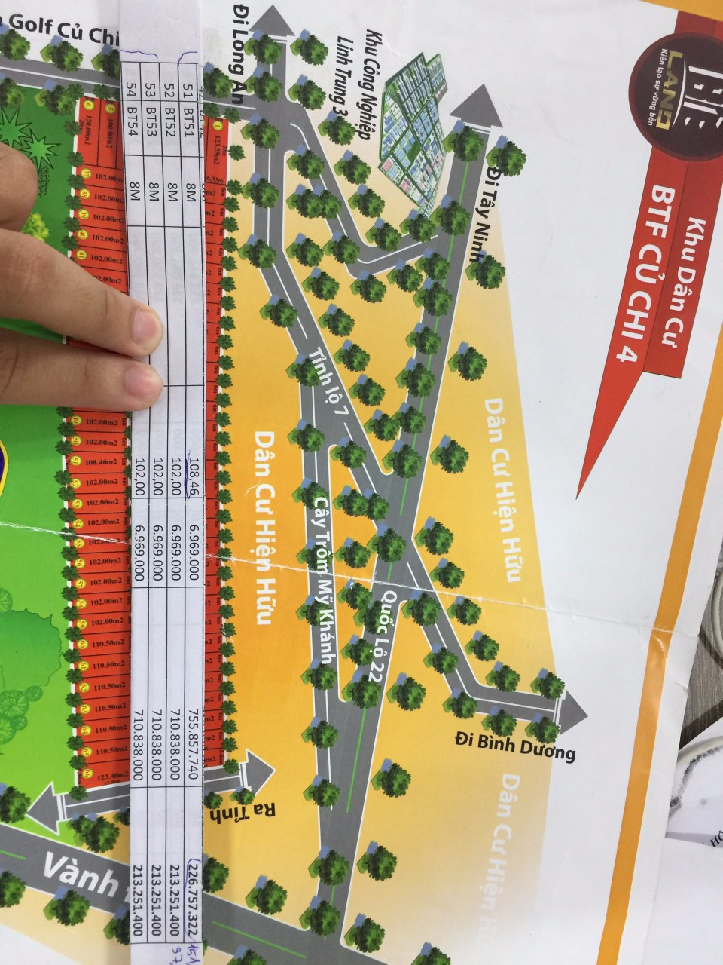
Tuesday:
Find customers, call and briefly introduce the company, Cu Chi project, about the benefits of customers when investing in. If possible, please make an appointment to talk specifically about the project to the customer.
Wednesday:
Meet the customers who yesterday contacted and agreed to the appointment today.
Thursday:
Continue to look for customers and make an appointment to introduce your project
Friday:
Report sales on the number of customers agreeing deposits and the amount of money collected from guests. Classification of guests from areas from districts in HCMC as well as other provinces. Classify the number of customers who buy the number of projects as well as the age and gender of the customers.
Meeting to report sales, share experiences and find directions and solutions to get customers
Sartuday:
Participate in training on issues related to the project in Cu Chi: about the number of existing plots, selling price, utilities around the project, the profits that will be made when investing. Regarding circulars, regulations, information on planning for construction of golf courts, industrial parks, hospitals ...
Training in sales techniques, techniques for capturing psychology, persuading and attracting customers
+ The third week: from 23/9/2019 to 29/9/2019
At the beginning of the week, the meeting was conducted to prepare for the first sale of Cu Chi project on Saturday weekend. The sale will take place right at the company's office. Planning to decorate rooms, food, drinks, gifts including: TV, motorbike, table fan, helmet ... Print company brochure, Cu Chi project, print legal documents, planning information and circular 60 on land book making, land separation .. Assign work to the technical team to make videos, movies, clips about the Cu Chi project, Slide introduce the project, about the form of profit payment, taking the book or the payment schedule in installments ... Assigning staff to welcome guests, staff as MCs, mobilizing the entire board of directors from the director, the heads of departments, the company's technical department.
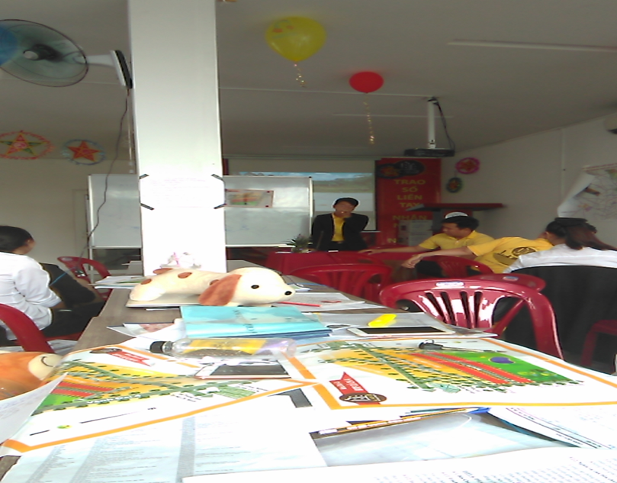
The view of preparing for the Opening saling project.
Thursday:
Organize for guests to come down to Cu Chi to visit the project. Rent 2 cars with 15 seats, prepare drinking water. Also rent a house, or a cafe under Cu Chi to rest guests, and staff will advise guests on the project and related issues. Bring a deposit slip, so guests can deposit as soon as they finish their tour.
Friday: Statistics of the number of visitors in the day to visit the project to make an invitation for the opening day on Saturday afternoon. Continue to perfect for the opening sale tomorrow afternoon
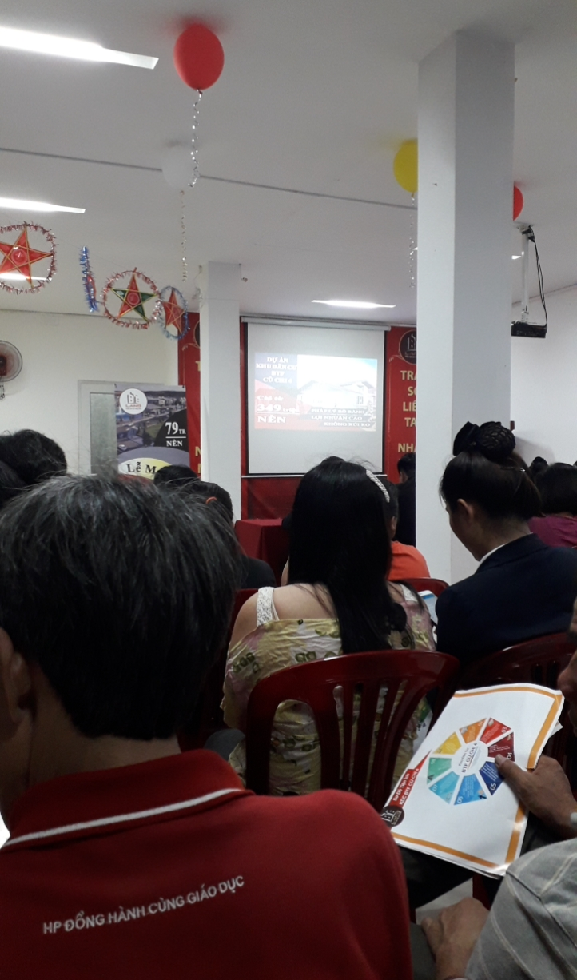
Saturday: Conducting the project sale
The view of Opening saling project.
+ The 4th & 5th week: From 30/09/2019 to 13/10/2019
I began to get used to the daily work of the room, get closer to my colleagues, learn from the experience of everyone who came first, share and express my difficulties and limitations to overcome. During these 2 weeks, my main job was to continue looking up the phone book companies provided and call for project advice to those in need. Use the skills learned in the training and learn from the direct instructor, from colleagues to convince customers for an appointment. The difficulty of my job is that the instructor asks to find as many foreign customers as possible. Every day I have to spend two hours to follow the instructions of the instructor so that he can guide, communicate the skills, the art of talking to guests. Thanks to the thorough and thoughtful guidance of my grandfather, I have learned a lot and I myself have also made progress through every working day.
+ The 6th & 7th week: From 14/10/2019 to 27/10/2019
In two this weeks, my main job is going to the market, participating in the sales pitches of real estate projects including: land plots, condominiums, townhouses, shophouses ... in companies, real estate corporations of domestic and foreign businesses. Mainly to learn, and learn how to speak to their customers. How do customers after listening to the presentation about the project, they put pen to sale. Refer to how they organize a sale, what will be presented, what content will be presented. What are the utility services in the sale, will invite those who participate to increase the persuasion of their project.
Act as an investor, infiltrating other companies, to see how their sales department employees work with customers? Which persuasive skills to use? Also go directly to projects in their inner cities and suburbs, see the prices they offer for that project. Through this, more information on the city's planning can be exploited. On the last days of the 7th week, I will write a report about the works that have not been done in 2 weeks going out. But they all learn from salespeople and their company, how they can successfully launch and launch a new project. After completing, I will give the group leader I read and review, then will give the direct instructor to draw experience for myself
+ The 8th & 9th week: From 28/10/2019 to 10/11/2019
I was completely familiar with the pace of the work in the room, from finding guests, to contacting to talking and meeting, and finally signing a contract with the customer. Everything went smoothly. I also got to know all the employees in the room, who could talk and share each other's work. It can be said that this is a very interesting job, it will help you train yourself every day with a lot of life skills. At the same time, this is a dynamic environment, because of sales pressures, everyone works hard, trying their best to earn as many contracts for the company as possible.
+ The 10th and 11th week: From 11/11/2019 to 24/11/2019
I finished the internship. However, I still work as normal and this week I put the papers related to my supervisor signature validation process successful internship ended. Everyone also held a small surprise party to celebrate our internship.
Finally, I concentrated review guidelines for completing an internship report completion quickly. Next I had to prepare to submit my finished report at LAU to confirm completion about two - months probation.
I am really thankful for everyone in the company who helped me realize many things in real work. I am sure what I learned here would be useful for my work in the future

CHAPTER 3
RECOMMENDATIONS TO IMPROVE IN WORKING SKILLS

3.1. The results that I contributed to internship company
Find customers for the company, sign a contract on saling platform 39, introduce and advise customers on ongoing and upcoming Cu Chi BTF5 projects after BTF4 from Cu Chi with price difference compared to Cu Chi 4 is 2 million.
Advise and explain to customers legal documents, circular 60 related to the content of land planning in areas in Ho Chi Minh City. Explain about the time, conditions, and procedures for making land books, splitting land plots, and transferring land use rights.
Take visitors for a tour of the project, advise customers of the adjacent projects that will be implemented such as industrial parks, hospitals, schools, shopping centers or supermarkets. Decisions on the construction of infrastructure, roads and bridges around the project will be purchased.
Assisting in preparing for the opening of Cu Chi 4 project, arranging rooms, chairs, printing posters for PR projects, preparing gifts for customers, displaying drinks and food for guests.
Complete all customer lists and filter entire customer groups, categorize loyal customers, leads, monthly sales reports, and contribute a few personal opinions for the development of Business Department.
3.2 The experiences gained when working in the sales department
- The experiences when dealing with customer
+ Call introduction, advice on the project for guests
. Attitudes and ways of talking: be gentle, smlie and cheerful. Create a friendly and reliable feeling.
. Understanding the needs and psychology of customers:
Customers buy investment or buy to stay in the future? How much money is there, asking about the direction, road in front of, area?
. Patiently convey brief but complete information
No rambling advice, especially not to quote customers via phone, to avoid the case that other exchanges call to check prices - retail
. Creating scarcity of goods:
Emphasizing that there is only a very small number of customers if they do not close to buy now, they will have to buy from other people later and of course they will have to buy at higher prices. Or Investor in the next time will increase the original price, so the selling price will increase ...
. Create business opportunities for customers:
There are only 2 lots left on the floor, giving information that in the coming time, the Investor will increase the original price ... Attract customers to work at the Floor for direct advice and review of goods. Take the actual model home.
+ Convince customers to buy the project after visiting or going to the floor
Understand the name of the transacting person, the financial capability, the details of the transacting person ... update all transaction contents with customers in the Company's management software.
• Redefining customers' need to buy real estate:
• Know the information of customers (customers are the first time to buy real estate? Or professional investors?)
• What are the personalities and buying and selling habits of customers?
• Social talk: How are you living in Europe? His profession ?…..
• Financial viability of customer? Customer is easy-going or difficult person? )
From there give out the most appropriate way of consulting for customers. Coordinate using open and closed questions just enough to explore needs: don't use too many open questions because they will dilute, cannot focus on the actual needs of customers, nor use too many closed questions. create a situation where customers answer curtly and uncomfortably like being questioned.
Newspaper for customers at the floor: Choose 1-2 lots reasonable and consistent with the needs of customers for advice. Do not give too many options to customers. From there, choose only 1 box to direct customers to. Need to swirl deep into the box you intend to sell. No rambling advice, no focus on affecting customer decisions (lots of companies enter at good prices, landlords need money to send money, prices lower than market).
Provide the selling price, compared with the current market price of some surrounding areas. Highlighting the advantages of real estate, showing customers that this is a very good investment opportunity at this time.
- The experiences when handing data
Update the details of the successfully-closed contract on the Company's intranet, File for management.
• It is recommended to store each file of new and old customers, especially for old ones, to update data on land prices, new projects, and planning information into the software on the phone to have timely solution when customers change requirements or require explanation or advice.
• Classify customers with specific characteristics, such as customers with financial difficulties, difficulties in making a book, difficulties in moving ... for appropriate support.
3.3. The experiences can be applied in life
- Confidence in communication
In order to gain confidence in front of everyone, the first thing you need is to have confidence in yourself by practicing your ability to speak in public. If there is something that forces you to interact or present in front of a large number of people, you should not give up, but boldly take the task and consider it a time for you to practice your speaking skills. In daily life, you should actively meet your friends and relatives and talk with them, first of all to learn from them the art of communication and behavior, and through those conversations will Help you feel more confident when talking. Start your story openly and naturally. It could be just the health questions, the funny stories that you meet in your daily life or the hot and interesting information that you just updated ...
In addition, to be able to have a successful presentation in front of the crowd, you need to understand clearly and make sure what you are going to say, understand the whole content of the problem. Should use accent, intonation and language formation to increase persuasion. At the same time, you need to be skillful in bringing funny stories, combined with asking questions to get comments from people. Avoid being solo all the time, which will make the atmosphere boring, and tired.
- Capture the psychology of the opposite person
In order to understand the psychology and understand the feelings of the other person, you should understand who you are talking about, what you do, how they live, have your thoughts or aspirations. What? In addition, during communication, you need to pay attention to all details related to their actions, thoughts, manners and attitudes. Because through those characteristics, we will understand what their personality is like so that it is easy to have a proper way to communicate.
At the same time, establish a solid relationship with the other person, to give the other person a sense of trust in you. When you give your partner a feeling of trust, they will be open and ready to express their feelings, aspirations, and desires. Once you do that, it will invisible to establish a bond between the two.
- Stay calm in solving problems
When you're having a problem with a client or the other person, keeping yourself calm, you need to:
+ First of all you need to help them calm down and make them feel that you have listened and really understand the problems they encounter, which will give the opposite person feel like they are being cared for.
+ Sit down and talk to the opposite person, discuss and discuss the problems that you are having and find the optimal solution for both.
+ Find out carefully what the cause of the problem is, what is the main cause and find the most appropriate solution
+ If you realize that it is your own fault, you should apologize, however, you should also know how to protect your viewpoint when you are arguing together, not completely at the discretion of others.
+ Pour a glass of water on both sides, which is also a way to ease the tension atmosphere.
+ No matter what the situation, should not express anger, always keep the density of the conversation in a peaceful state.
3.4. Solutions to improve the operational efficiency of the sales department
- Improve the working skills of Sale staff
In addition to the required qualifications, sales staff need to focus on the necessary ethical and disciplined qualities at work. Specifically:
+ Good communication and negotiation skills
This is an extremely important prerequisite for an excellent salesman. This skill helps employees easily access, exchange information and successfully negotiate to help build close relationships with customers as well as consulting to help customers trust when using the products and services of his business.
+ Flexible, sensitive, knowledgeable at work
Must update all information of society, consumer tastes through market penetration, from which to have practical knowledge, cleverly devise appropriate solutions to help customers choose products. service that suits them.
+ Master the information about products and services for sale
Knowing the information about the products and services provided by the company is mandatory for sales staff. Of course, only when you know the products and services you provide, you can give reasonable and accurate consulting solutions to customers, helping the opportunity to close high orders to increase sales for the company. When you're not sure, no one believes in your company.
+ Sales staff must be people with high bravery, intelligence and insight
+ Always align both internal and external knowledge
Must always take care of appearance, bright face, neat hair, trendy, polite clothes, warm attitude, always keep smiling on the lips to be able to contact and consult products for customers. This helps to increase the order-closing ratio and bring revenue to the company.
+ Proficient in all the support tools for the job
Sales people need to supplement their necessary skills to support the job such as the ability to communicate fluently in English, proficient use of office applications such as Word, Excel, PowerPoint, Outlook and Internet. , knowledgeable about internet and website, advertise online, have a good "team work", get along well with colleagues, coordinate well at work, from which the work will be more smooth and convenient.
- Improving the quality of customer care
Real estate is an industry where customers have to spend a lot of investment and if you cannot make them comfortable, you may lose a lot of opportunities to get a contract. Good customer service makes customers feel that you understand the problem they are facing and are on their side. Such a feeling is absolutely essential to motivate customers to make investment decisions.
+ Strengthen customer care skills of employees
The first thing every business owner thinks of "how to improve the quality of cskh service" is to improve the customer service skills of employees. So which skills need to be advanced?
• Understanding of products - services
• Convey clear messages
• Sympathy, patience
• Adaptability
• Professional ethics
• Learn customer feedback
• Pay attention to sensitive issues
+ Improving interaction with customers
The staff is equipped with the necessary customer care skills, which is a good start. but they need to be more in touch with their customers, making sure their skills are not lost.
• Listening is a habit that will help you gain respect from your customers.
• Clarify and repeat what buyers say to make sure you understand them.
• Sympathize with emotions and thoughts.
• Acknowledge your mistakes.
+ Strengthen customer care strategy
In order to please others in addition to the skills of the staff, a clear, specific customer care strategy is also needed. Actively let them feel satisfied before they reach you to solve your problems.
+ Rewarding loyal customers
Stay in touch, and give them something valuable in exchange for their time, attention and investment. This does not need to be too valuable, sometimes just as simple as: coupons, announcements about special events, useful details and tips or news they can use effectively. Just remember: If you do not keep in touch with your customers, your competitors will.
+ Using Customer Management software
This tool focuses on customer contact information, leads, and the history of interactions with you. Based on that, the company captures customers' needs to come up with appropriate strategies to retain them. Providing a good experience for users that makes them satisfied, trust and remember your brand when in demand will bring long-term revenue.
- Developing an effective marketing strategy
A carefully constructed marketing strategy will help you get positive sales and easily control your business. Should be based on the following directions:
+ Identify and research target markets
This is probably the number one marketing strategy you can use to increase sales for your real estate project.
Real estate brokers and businesses should focus on the target market that is suitable for their real estate project and strive to become the leading real estate business in that market. This makes it easier for you to outline ideas about what to do to reach your target audience, plan for dealing with market risks, and most importantly, provide a solution. The project is suitable for competitors who are leading in the short and long term.
+ Expanding the budget for marketing campaigns
Another important factor to increase real estate sales is to invest more budget in its real estate marketing campaigns.
There are many costs to implementing a real estate marketing plan, such as the cost of real estate websites, the cost of advertising for digital channels, the cost of media and PR plans for project,…
The thing to keep in mind here is that your spending must be properly allocated and directed to the target audience for your real estate project. For example, customers in urban areas can promote real estate marketing campaigns through online marketing channels, or for customers in rural areas, they can promote methods like distributing leaflets, hanging advertisement banners, ...
+ Building a project website and use digital marketing channels
Regardless of your target market or project, the first thing to do for a real estate marketing plan is to establish your presence on the internet using a professional website, as well as advertise for the project. on your social networking sites like Facebook, Zalo, ... These jobs need to be implemented strategically and properly so that the results can bring great potential in reaching the target customers.
You can also conduct your real estate marketing campaign through search engines like Google and Coc Coc with paid advertising campaigns. Some effective advertising methods for these tools can be mentioned as Google Adwords, display network advertising, remarketing.
+ Promoting sales through word of mouth marketing
Promoting transactions through referrals from previous clients is considered one of the most effective real estate marketing options.
It is easy for new clients to select real estate projects when referred by friends, colleagues or relatives. You can always promote this approach by offering incentives when someone introduces a new client to your real estate project.
+ Responding to customer needs quickly
We live in a world that is moving faster than ever. It is very important in this real estate marketing strategy to answer the customer's questions as quickly as possible or else you risk losing those customers.
You must always ensure that you respond to customer requests as soon as possible. You cannot delay answering your customers' questions today for the next day. Responding to customer inquiries quickly will add credibility and reputation to the real estate business.
+ Regularly posting news about real estate projects
If you want to quickly increase your real estate sales and be serious about your long-term success, then regularly posting real estate project news is considered an effective method, including investor news, about the utilities of the project, the interests of the homeowner, the vivid images of the project, or simply the progress of the real estate project.
All current and potential customers will appreciate the information from such newsletters, because it demonstrates your benefits and commitment to customers.

CONCLUSION

First of all, with the deepest and most sincere affection, allowing me to express my gratitude to all the individuals and organizations who have facilitated and supported me throughout the learning and research process. this talent. After more than 3 months of internship in the sales department of Tan Thanh Dat Company. Although the time is not much, I have learned a lot of practical experiences which is very helpful for my current job as well as in life.
It is the time for me to recognize some advantages and disadvantages clearly so that I have more experience and I know better how to improve myself.
To have knowledge and practical experience like today, I would like to sincerely thank the teachers of the Department of Foreign Languages, Long An University of Industrial Economics. Teaching and equipping her with basic knowledge and at the same time, creating favorable conditions for her to complete her graduation report.
I also sincerely thank the help of colleagues, brothers and sisters at the company enthusiastically guided and created favorable conditions for me during the internship.
With the knowledge and experience I have gained from the Foreign Book sales of PNR, I have been more self-confident that I can apply them in my future career.
Due to the limited time for practice, the level of qualification is still limited, so my harvest could not avoid mistakes. I look forward to your guidance and suggestions so that I can supplement and improve my consciousness, better serve the actual work in the future.
Thank your sincerely!

